AN LAC SEAFOOD CO., LTD. (HK216)
No. 38, 2A Street, Hung Vuong South – Tran Van Kieu North Residential Area, An Lac Ward, Binh Tan District, Hochiminh City, Vietnam.

No.: 09/ALC/ 2011
STATEMENT
TO.: SHING YUEH INTERNATIONAL CO., LTD.
DATE | INVOICE NO. | AWB | TOTAL
15 MAR. | 024/ALC | 695 3323 8332 | 5,932.07
17 MAR. | 025/ALC | 695 3323 8343 | 11,336.41
17 JAN. | 07/ ALC  VAT  TOTAL | 695 3379 9054 | 12,123.00  2,763.00  14,886.00
17 JAN. | DAMAGE OF EACH PART  TRANSFER 1  REMAIN |  | 7,443.00  3,523.80  3,919.20
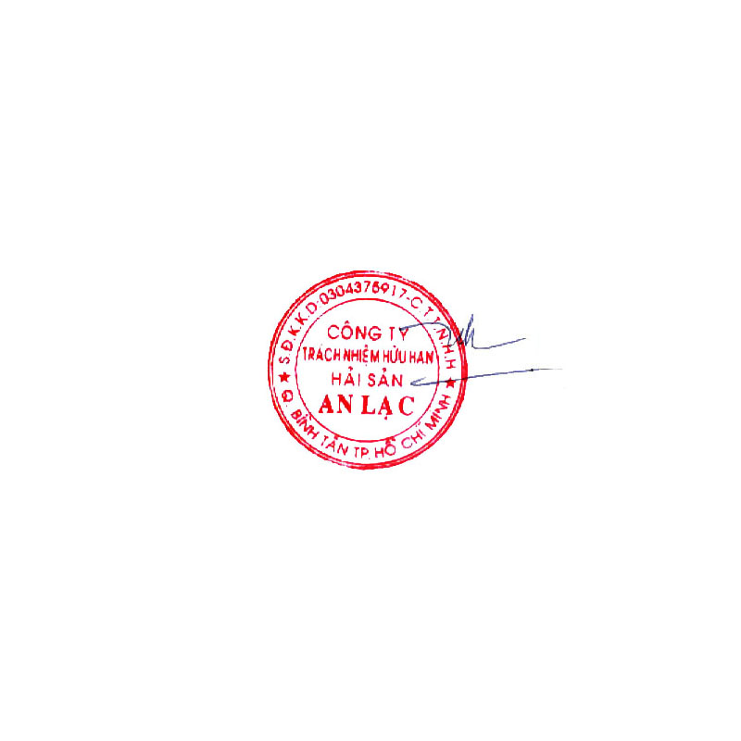  GRAND TOTAL |  |  | USD 21,187.68
Says: US DOLLARS Twenty – One Thousand One Hundred Eighty Seven And Sixty-Eight Cents Only.
AN LAC SEAFOOD CO., LTD.
Account No. : 1402 1485 100 3419
Name Of Bank : EXIMBANK, DISTRICT 4 BRANCH, HOCHIMINH CITY, VIETNAM.
SWIFT : EBVIVNVXQ04
AN LAC SEAFOOD CO., LTD.

Leâ Thị Hoa

